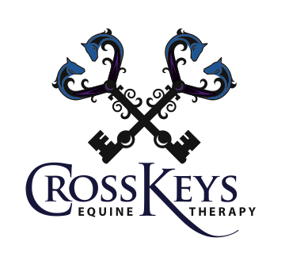

HORSE POWER 4 MILER

A walk/run to benefit the programs of Cross Keys Equine Therapy.

Top of Form

Name: Male Female Age



Bottom of Form

(Last) (First)

Address:

(Street) (City) (State) (Zip)

Email address: Phone:

Entry Fee: Donations:

Top of Form

$15 by April 10 $50 $25 Other



$20 after April 10 & Event Day

Amount enclosed for fee: Amount enclosed for donation:

Bottom of Form

Top of Form

Shirt size S M L XL Availability of T-shirts not guaranteed after April 10



Bottom of Form

I hereby, for myself, my heirs, and executors waive, release and forever discharge any and all rights and claims for damages which I may hereafter hold against the organizers and sponsors of the Horse Power 4 Miler, and verify that I am physically fit and have sufficiently trained for the competition of this walk/run. Further, I hereby grant full permission to any and all of foregoing to use my name, photograph, videos or any other record of this event for legitimate purpose, without compensation. I understand that bicycles, skateboards, roller skates or blades, animals and radio headsets are not allowed in the walk/run and I will abide by this guideline. I understand that if the walk/run is canceled due to circumstances beyond the control of the Horse Power 4 Miler committee, my entry fee will not be refunded.

Date:

Must be signed by runner or parent or guardian if under18.

Race #

Mail to:

Cross Keys Equine Therapy

6711 Stoney Lick Road

Mt. Crawford, VA 22841

Make checks payable to Cross Keys Equine Therapy

No refunds. No confirmation will be sent.

Event will be held rain or shine.

Duplication of this form is encouraged! Please pass the word!