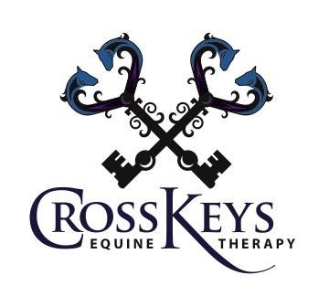

2023 Fees for Services

Individual Equine Assisted Psychotherapy (EAP) Session: $150/hr
Individual Equine Assisted Learning (EAL) Session: $150/hr

Group EAP/EAL (6-8 people, 4x or more): $85/person

Group EAP/EAL (6-8 people, less than 4x): $105/person
$85/additional person

